Q3. Select All

Query all columns (attributes) for every row in the CITY table.

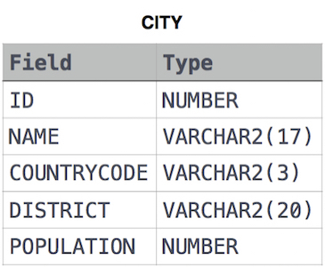The CITY table is described as follows:

Ans.

SELECT \* FROM CITY